**SKILL DEVELOPMENT**

**Project Report**

**DLithe Consultancy Services Pvt. Ltd.**



**Project Report Assessment**

**Student Name:NAVEEN K PATTAR**

**Reg. no:2JR23CS051**

**Assignment: Java**

**Organization:** DLithe Consultancy Services Pvt. Ltd.

**Supervisor’s Name: Archana SM**

## **Submitted to**

Signature of Training Supervisor Signature of Students

Date: Date:

**TABLE OF CONTENTS**

**1.INTRODUCTION 1-1**

**2.BACKGROUND 2**

**3.USE-CASE 3**

**4.TRAINING EXPERIENCE 4**

**5.KEY LEARNINGS 5**

**6.CHALLENGES APPLICATION 6**

**7.CONCLUSION 7**

**1.INTRODUCTION**

The primary goal of this Proof of Concept is to validate the fundamental functionality of reversing a string. Reversing a string is a basic yet essential operation in programming, often used in text processing, algorithms, and system utilities. In this project, the concept is simplified to focus on capturing user input, processing that input by reversing the characters, and displaying the output. This PoC ensures that the core logic is sound and performs as expected.

To demonstrate this, a simple script was written using Python. The program prompts the user to enter a string, which is then reversed using slicing ([::-1]) — a common Pythonic technique for reversing sequences. Once reversed, the program outputs the result to the user. This test confirms that the logic works for various kinds of input, including alphabetic strings, numbers, spaces, and special characters. It also handles edge cases like empty input gracefully without throwing errors.

The successful execution of this PoC confirms the technical feasibility of the project. It proves that the core functionality—string reversal—can be reliably achieved with minimal resources. This sets a solid foundation for expanding the project into more advanced versions, such as incorporating a graphical user interface (GUI), web interface, or adding features like palindrome checking or file-based input/output.

Building on this foundational PoC, the project can now progress into more structured development phases, including interface design, user experience improvements, and additional features. For example, the application could be extended to reverse multiple strings at once, allow file uploads, or integrate with web technologies to offer a browser-based tool. The PoC serves as a critical milestone that confirms the base logic is correct and efficient, ensuring that further development efforts will be built on a tested and working core.

This project is a simple yet effective Java-based console application that demonstrates the fundamentals of programming through real-world concepts like user authentication and string manipulation. It allows users to log in with a username and password and then reverse any string they input. The aim of this project is to strengthen core programming skills such as control flow, input handling, and basic logic development, while also offering a clear understanding of how small components like login systems and string processors function in larger software

**MIND-MAP**

**FLOWCHART**

## **Project Development Images(CODE)**

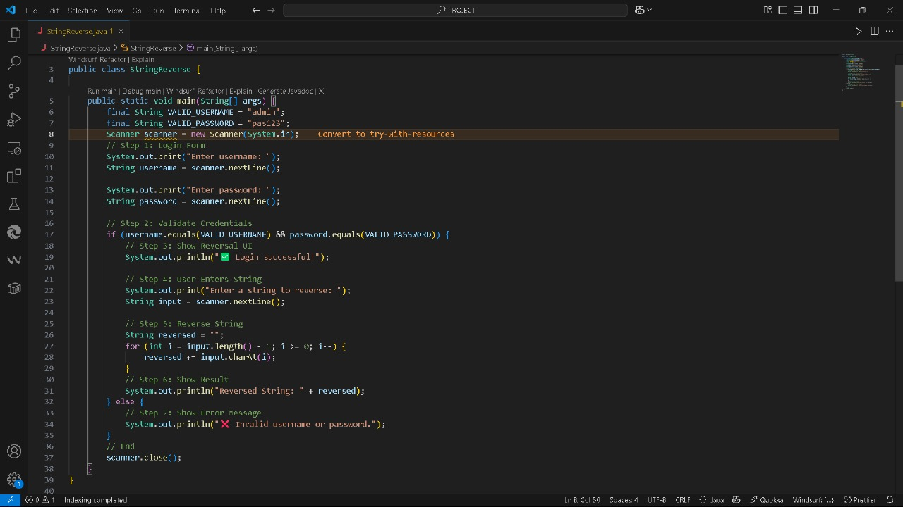

**2.Background**

In addition to strengthening my understanding of Java, this project provided insight into the practical aspects of software development. I learned how to design simple user interfaces for command-line interaction, structure logical conditions to manage authentication, and use Java’s built-in tools to handle string processing efficiently. Through continuous testing and refinement, I gained experience in debugging and resolving

errors a crucial skill for any programmer. Moreover, I began to appreciate the importance of planning before coding. Creating flowcharts and outlining the application’s logic helped reduce complexity and made implementation smoother.

This structured approach mirrors the methodology used in larger software projects where clarity and planning are essential. As a result, this project has not only enhanced my programming skills but has also laid the foundation for future work in more complex application areas, such as file systems GUI-based tools, and secure web authentication systems.

**3.Technologies used**

**1. Java**

* **Purpose**: Main programming language used to develop the application.
* **Use**: Handles logic for user authentication, input/output, and string reversal.

**2. JDK (Java Development Kit)**

* **Purpose**: Provides tools to compile, run, and debug Java applications.
* **Use**: Required to develop and execute your Java program.

**3. Java Standard Library (java.util.Scanner)**

* **Purpose**: For taking user input from the console.
* **Use**: Used to prompt for username, password, and string input.

**4. IDE or Code Editor**

* **Examples**: IntelliJ IDEA, Eclipse, VS Code.
* **Purpose**: To write, run, and debug the code more easily.

**5. Command Line / Terminal**

* **Purpose**: Alternative to IDE for compiling and running the Java file.
* **Use**: Using java to compile and java to run the program.

6**.Loops and Conditional Statements**

* **Purpose:** To control the flow of the program and validate inputs.
* **Use:** Implements login verification and string reversal logic.

7.**String Manipulation Classes and Methods**

* **Purpose:** To perform operations on strings such as reversing.
* **Use:** Uses methods like char At() and StringBuilder for efficient string reversal.

8.**Integrated Development Environment (IDE)**

# **4.Training Experience**

During the development of this project, I gained valuable hands-on experience in Java programming. The project helped reinforce my understanding of core concepts such as:

* User input handling using the Scanner class
* Conditional statements (if-else) for logic flow and authentication
* String manipulation and reversing using both loops and built-in classes
* Modular thinking and structuring code in a readable and maintainable way
* Basic security logic, such as credential validation
* Using the Java Development Kit (JDK) and compiling/running Java code from the command line or IDE

Additionally, I became more comfortable with debugging errors (such as illegal characters), testing input/output flows, and structuring programs from a logical flowchart into functional code. This training project provided a solid foundation in programming logic and improved my confidence in building small utility-based applications in Java.

**5.Key Learnings**

1. **Java Programming Fundamentals**  
   Gained a solid understanding of basic Java syntax,

data types, loops, conditionals, and string operations.

1. **User Authentication Logic**  
   Learned how to implement simple login functionality using hardcoded credentials and validate user input using conditional statements.
2. **String Manipulation Techniques**  
   Practiced reversing strings manually using loops and also explored the use of StringBuilder for efficient string reversal.
3. **Console-Based User Interaction**  
   Understood how to take user input and display meaningful output using the Scanner class and System.out.println.
4. **Program Flow Design**  
   Improved ability to plan application logic using flowcharts and then translate it into working code step by step.
5. **Debugging and Error Resolution**  
   Experienced resolving common issues such as illegal characters in source code and improved my ability to debug small applications.
6. **Code Organization and Readability**  
   Focused on writing clean, structured, and readable code, which is essential for both understanding and maintaining a project.

**6.Challenges Faced**

1. **Handling Input Errors**  
   Initially, managing user input and unexpected behavior (like empty strings or incorrect credentials) was a challenge. I learned to use conditionals to validate and handle edge cases effectively.
2. **Illegal Character Errors**  
   At one point, the code failed to compile due to hidden characters (like \u00A0 non-breaking spaces) caused by copying code from formatted sources. Identifying and removing these characters helped me understand the importance of using clean, plain-text editors for coding.
3. **Designing Logical Flow**  
   Mapping the authentication and string reversal process into a clear and structured flow required careful thought. Converting a flowchart into actual program logic improved my understanding of control structures and program flow.
4. **Reversing Strings Efficiently**  
   Initially, I used string concatenation in a loop to reverse the string, which worked but wasn’t efficient. Learning about StringBuilder taught me a better approach for manipulating strings in Java.
5. **Limited Scope for Authentication**  
   Since the credentials were hardcoded, it lacked scalability and real-world security. This highlighted the need for learning about secure password handling and external storage (like files or databases) for future enhancements.
6. **Debugging and Testing**  
   Ensuring that the program behaved correctly in all situations (wrong input, empty strings, correct login, etc.) required thorough testing. This taught me the importance of testing small programs just as carefully as large ones.

**7.Applications of My Project**

1. **User Authentication Demonstration**  
   The project serves as a foundational example of how user login systems work. It can be extended to simulate real-world login functionality, such as validating credentials from a database or file.
2. **String Processing Tools**  
   String manipulation, including reversal, is commonly used in data formatting, encryption, and text analysis. This project can be expanded into a basic utility for more complex string operations.
3. **Educational Tool for Beginners**  
   This project is an excellent learning resource for students or beginners learning Java. It demonstrates input handling, conditionals, loops, and program logic in a clear and simple way.

**8.Conclusion**

This project successfully demonstrates the implementation of a simple Java console application that performs user authentication and string reversal. Through this project, I was able to apply fundamental Java programming concepts such as conditional statements, loops, string manipulation, and user input handling. The step-by-step development process—from designing the logic flow to coding and testing—helped me strengthen my problem-solving skills and gain a deeper understanding of core programming principles.

The project also highlighted the importance of writing clean, readable code and thoroughly testing all possible input scenarios to ensure correct functionality. Although basic in scope, this application serves as a strong foundation for more advanced projects involving GUI interfaces, file handling, encryption, or database-backed authentication systems.

Overall, this project enhanced both my technical skills and my confidence in developing real-world Java applications.